**Solution 2**

Analysis:

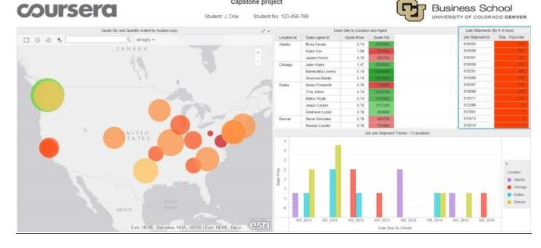

In the Quote quantity and quantity by location, you can easily see in the map chart that we

have derived the locations for zip codes providing information about the quantity ordered

and the number of subjobs listed for that particular location. The bubbles in the above visualization shows the bubble chart for the areas by the quantity ordered.

In the Lead generation by location and agent visualization, information about the quote price and the quantity by Sales agent for cities like New York, Chicago, Los Angeles and Seattle are displayed. The quote quantity in red denoted the lowest quote percentage for

the particular city. In the Job and Shipment trends to Location, the bar chart displays information about the Ship dates by week for locations on basis of their base price. It is seen that the base price decreases by week in 2014. For Shipment days late, information is

displayed about the days the shipment was delayed by for a particular Job Shipment id.

Dashboard 2: Invoice Trends

Analysis:

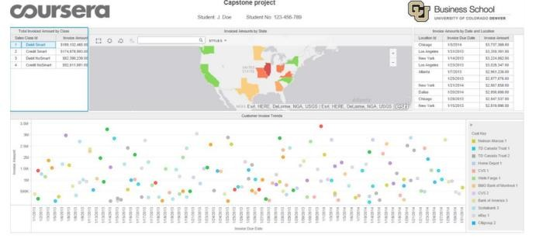

This grid data shows information about the invoice amount for the Sales class Id for four different types of cards generated by CPI Inc. The invoice amount by state shows us the regions in United States by the invoice amounts. The regions showing green color have the highest invoice amount and the ones with red have the lowest.

Customer invoice trends displays information about the invoice amount by the invoice due

dates with correspondence to the customer keys. This graph displays the information about the Customer Invoice Amount trends by Invoice due dates and the reflecting Invoice

amount which helps us understand how the Invoice amount changes over the period of time for each customer.

Invoice amounts by date and location, similar to the previous graph, shows grid data

information about the due dates for Invoice amount by the location id.

Dashboard 3: Financial Summary

Analysis:

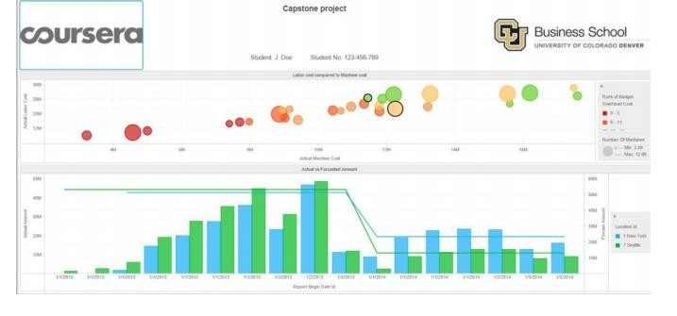

From the above bubble chart it is seen how the budget overhead cost compares in relation

to the Actual machine cost and Actual labor cost. The below graph reflects the changes for the bubbles in relation with the machine type and location. The bubbles in red shows the lowest budget overhead cost and the ones in green show higher overhead budget cost.

Conclusion: From this analysis, we understand the key performance indicators of the CPI Company and the profit it has generated over the time period for particular regions. The job and shipment trends, invoice trends and the financial summary give us an overall idea about the CPI growth and also tells about the areas they need to improve on.